26. Atfanand a container of water were connected fo a circuit as shown below.

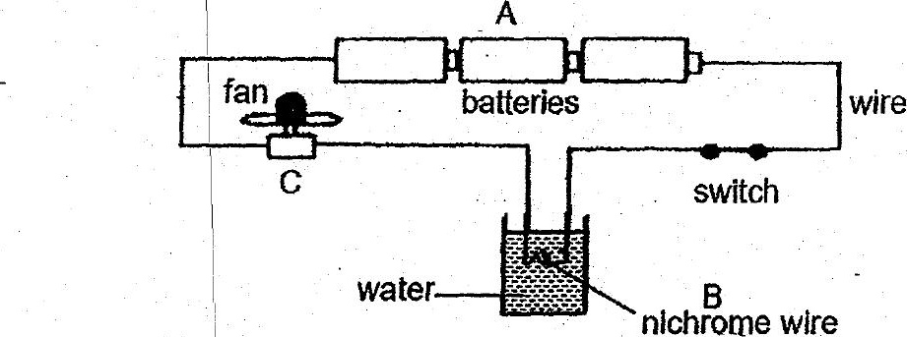

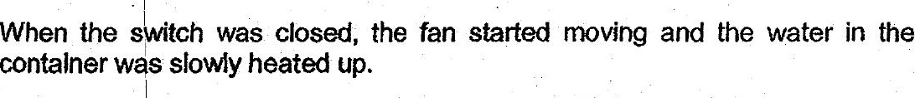



PA  
:  
(1) Chemical potential energy | Electrical energy > Kinetic energy >  
> electrical energy light energy sound energy  
(2) Electrica energy > kinetic | Electrical energy > | Electrical energy >  
. energy . light energy sound energy  
| :  
|  
. (3) Chemical potential energy | Electrical energy > | Electrical energy >  
> efectrical energy heat energy kinetic energy  
; |  
(4) Electrical energy > kinetic | Heat energy > light | Kinetic energy > _  
| energy energy heat + sound energy