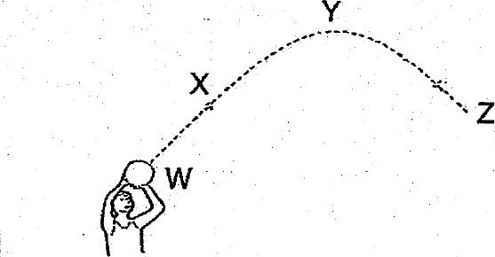

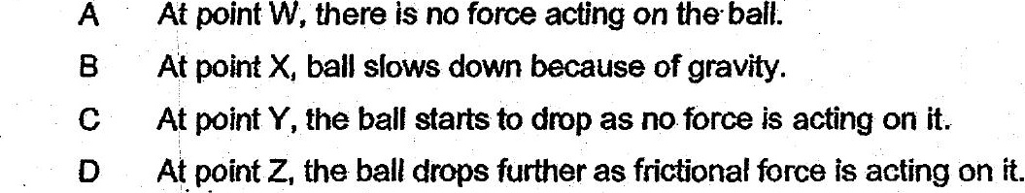

(1) Bonly  
  
(2) AandB only  
(3) Gand Donly  
(4) A,BandDonly

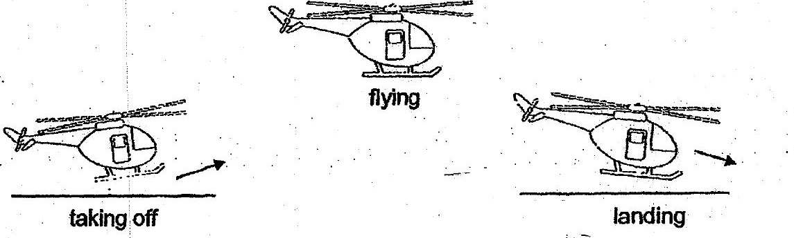

(1) ‘Landing only  
  
(2) Taking off and flying only  
  
(3) Taking off and landing only  
(4) _ Taking off, flying andanding