CHIU ST NICHOLAS GIRLS’ SCHOOL



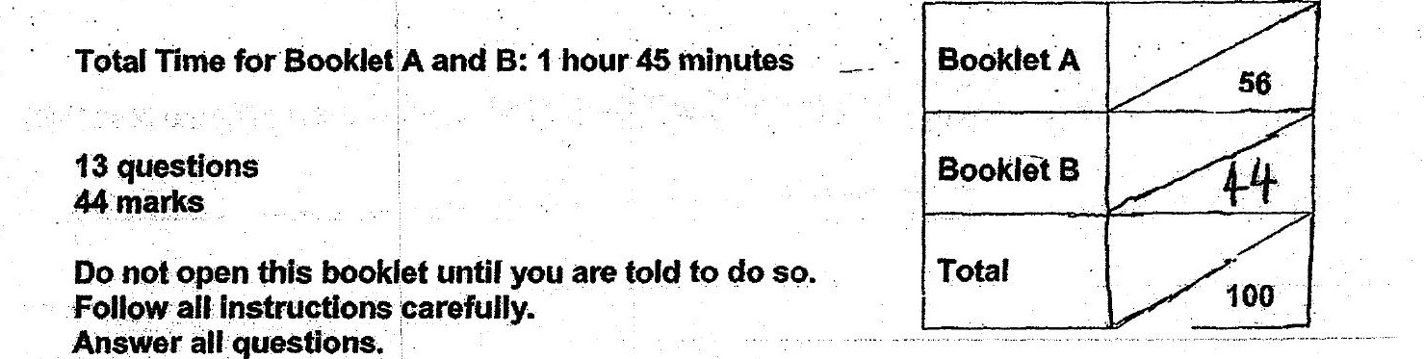

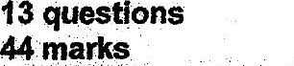

This paper consists of 15 printed pages.

