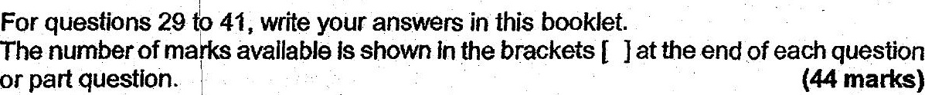



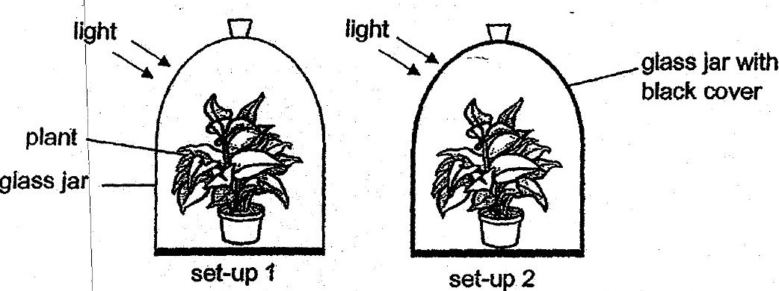

a (a) What is the purpose of set-up 1?

(b) Based on her experiment, how can Mary confirm that light is needed for  
photosynthesis? : (2]

(c) Whats produced during photosynthesis that is needed by the plant ? [1]

