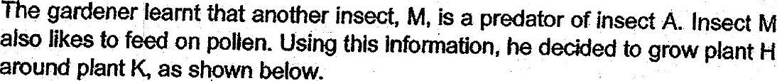

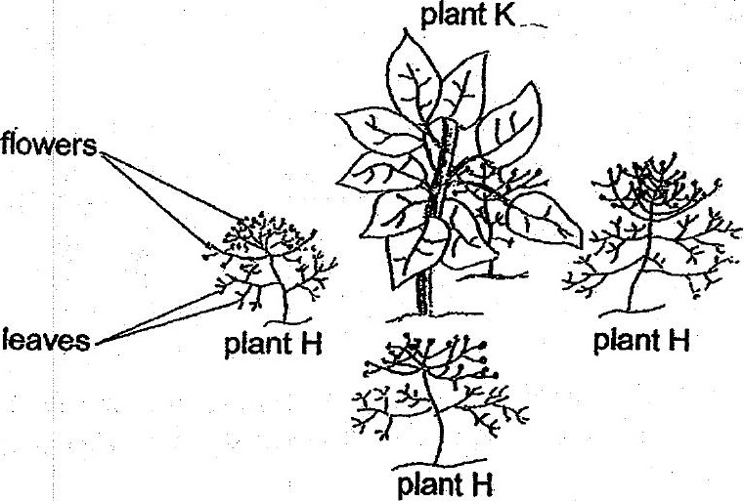

Based on the Information above, explain how this planting method allows the  
gardener to grow plant K without the use of pesticides? f2]

