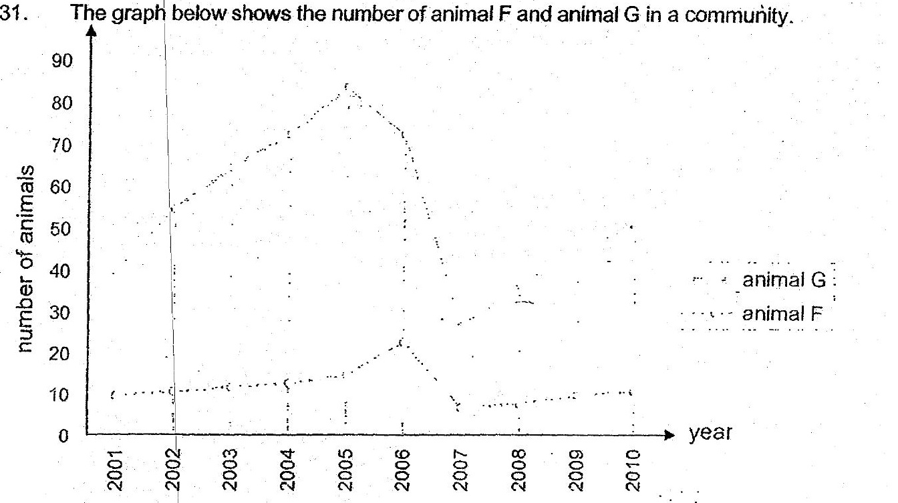





(b) Based on the graph given above, there was a period with very little  
rainfall So



(c) Other than lack of water for the predator, Give another possible reason. |  
why with very little. rainfall would cause a decrease in the population of  
the predator. = {1]

