(d). . The forest where organism B lives in is being cleared for building of new  
houses. How. will this affect the population of Organism B? Explain your  
answer.’ . (1]

(a) \* Deforestation can also lead to global warming. Explain why. 1]

34. The diagram below shows a table fan.

(a) | Complete the conversion of energy when the switch ts turned on. — (7

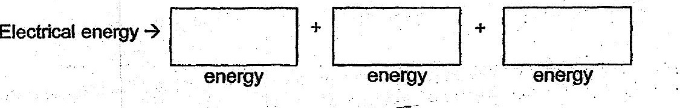

(b) . Explain why the fan continued to spin for a while even after the switch  
was-turned off. a it}

