35. Nathan made paper flyer A with a paper clip as shown in the diagram below.

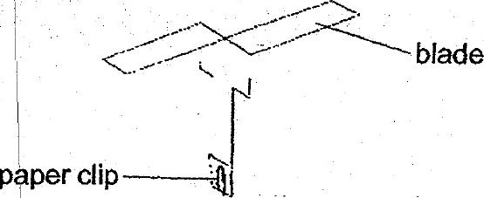



|  
(a) What must Nathan measure to help him draw a conclusion? {1]  
|

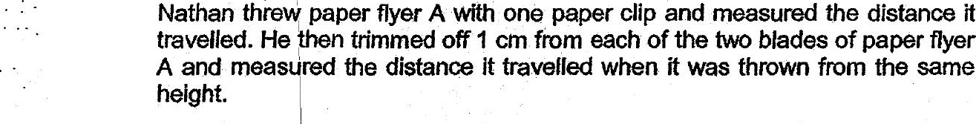

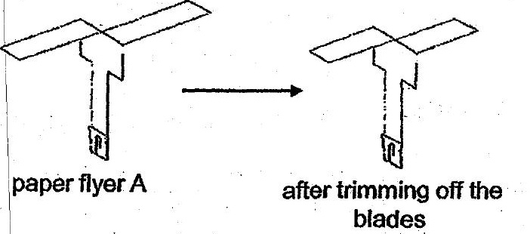



|  
(c) Name one fruit or seed with a similar structure like paper flyer A. {1  
r

