

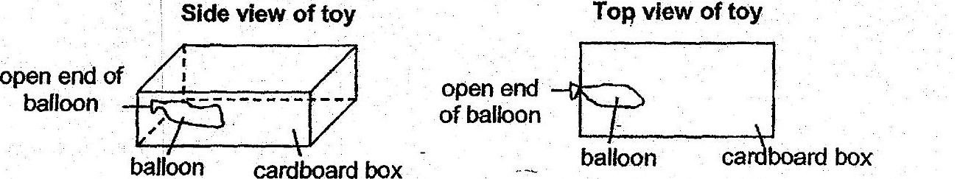

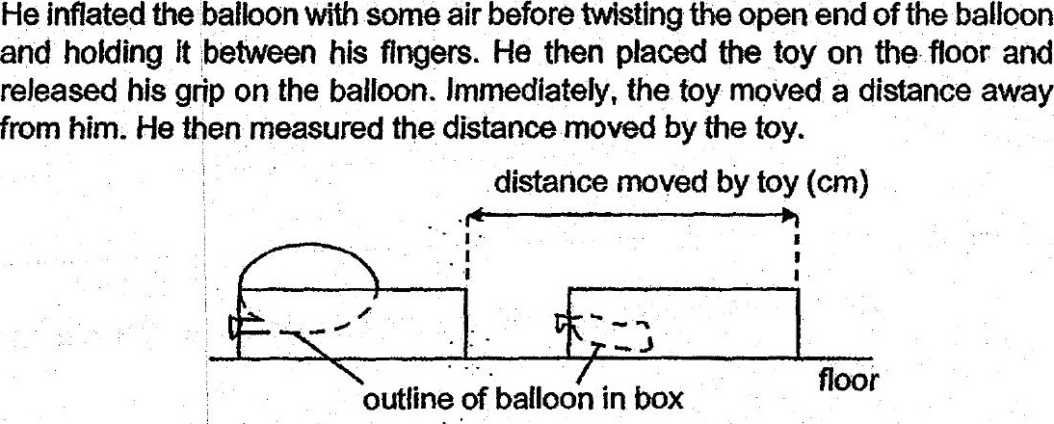



(a) Whatcan Lennard do to make his experimental results more reliable? [1]



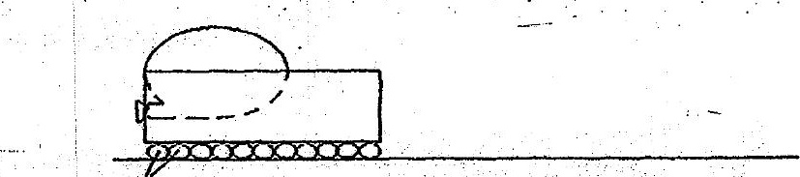

(b)' Would. the toy move-a shorter or longer distance than before? Explain

