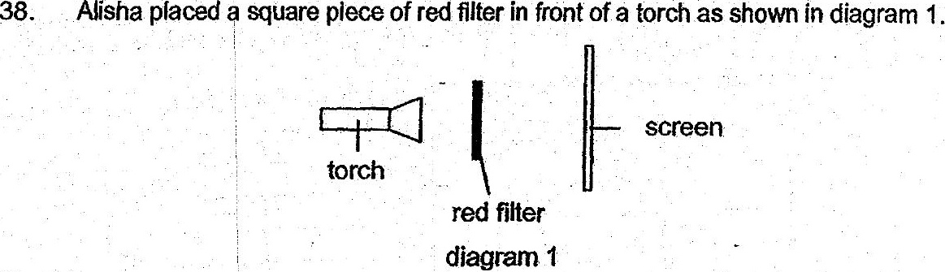

When the torch was switched on, she noted a Square. patch of light on the  
screen. She then repeated the same experiment with blue and green filters.  
  
+ Colour of filter used | Colour of square patch of light  
Pe  
ee ee  
  
(a) What was the aim of Alisha's experiment? {1]

Allsha then placed a can of drink behind a red filter as shown in diagram 2.

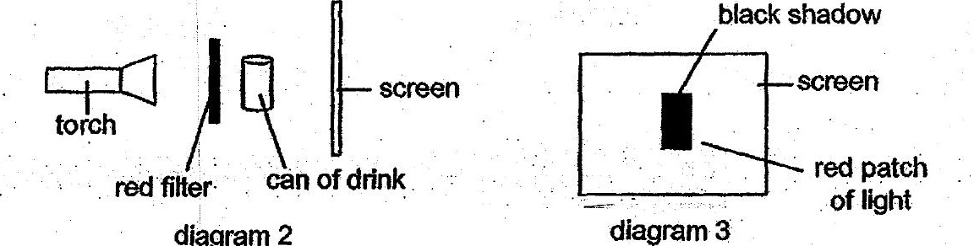

(b). .. Diagram 3. shows what. she saw on the. screen when the forch was  
switched on. Give an explanation for Alisha’s observations in diagram 3.  
Ce : [2]

