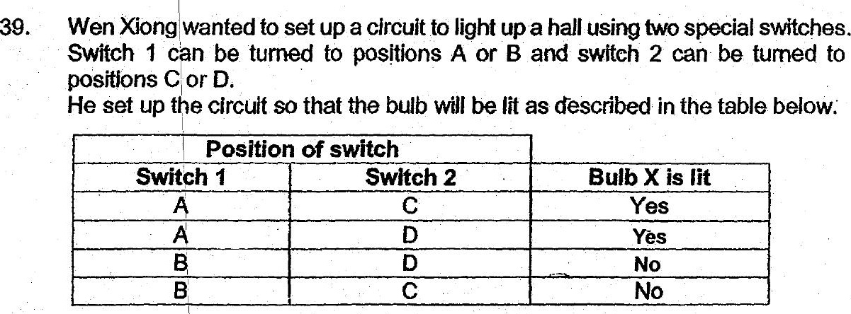

(a) The diagram below shows part of the circuit. Complete the circuit so that  
it will work as described. [2]





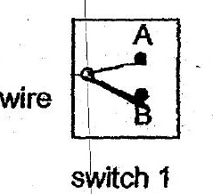

ne ‘  
|" (b)_ fone more bulb is added to the circuit in series, how would it affect the  
Sa brightness of bulb xX? me (1)



