

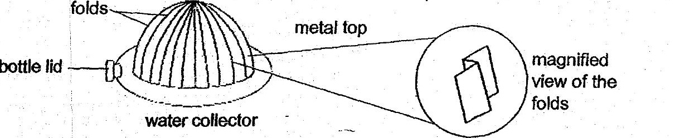

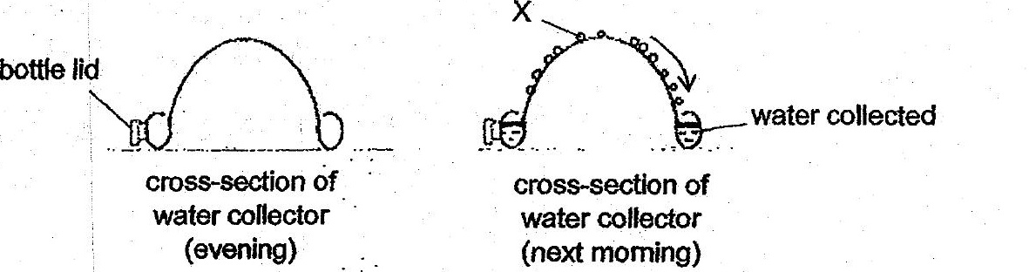

(a) Whatis X?

(b) - Explain why metal is used to make the fop part of the water collector. [2]

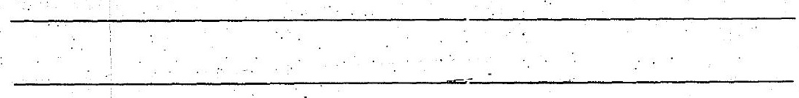

(c) Explain why there are folds in the metal top.

