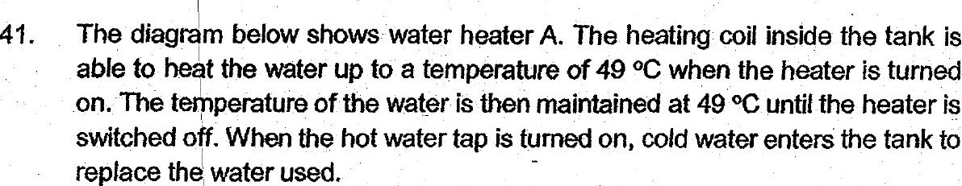

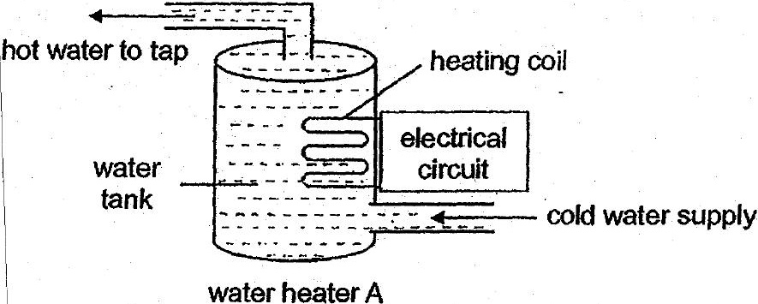



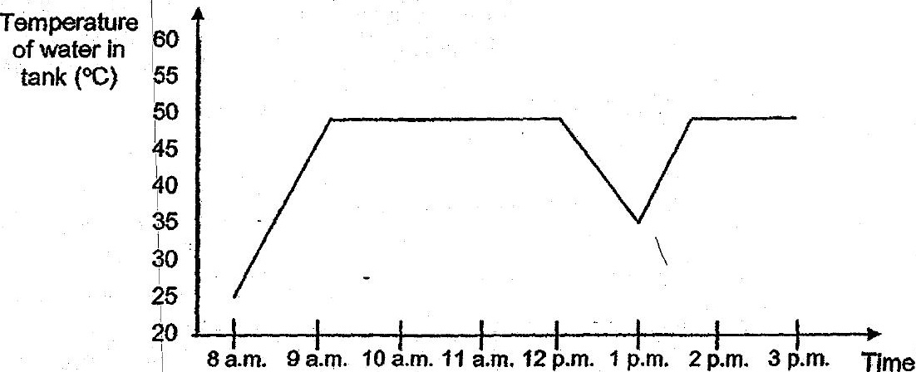

(a) How tong does it take for the water in the tank to heat up to 49°C? = [1]

(b) Jia Ming took.a bath. during the. period shown In the graph. Based onthe  
graph above, what fime did he probably take his bath? {t]