(c} While bathing, Jia Ming noticed that the temperature of the water was  
not as hot as when he started bathing. Give a reason why this is so. [1]

The diagram below shows water heater B. This type | of water heater does not  
store water in a tank. When hot water is needed, the heater is switched on. and  
cold water passes through. the heater to be warmed up before leaving the  
heater, The water heater takes about 5 minutes to heat up the water to a  
temperature of 49 °C. :

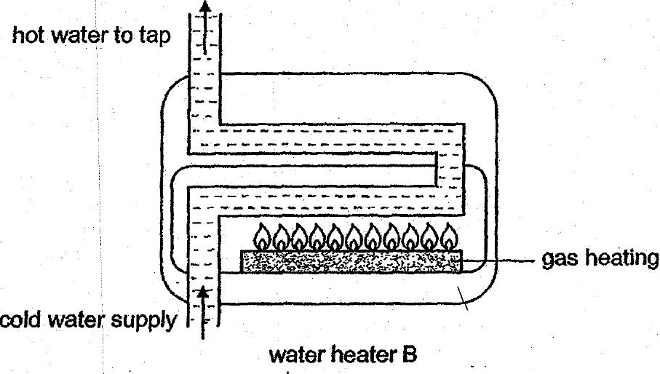

(d) Which water heater A or B Is more energy saving? Explain your-choice.  
. i : . (t}



