3. The table below shows the stages of development of a fertilized human egg.

Ferlilized egg implants itself in the womb



(1) After 7* week  
  
(2) After 8° week . :  
(3) After 16 week :  
(4) After 38" week

4. _ Reforestation is a process of replanting an area with trees. Which of the following are  
the banefits of reforestation?

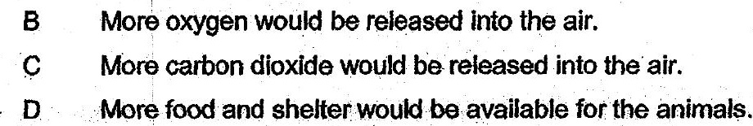

(1) AandB ony  
  
(2) Cand Donly  
  
(3) . Band D-only  
(4) ABC and D