

: Organism K feeds-on Organism. J.  
; Organism F and J feed on Organism H.  
e| Organism G feeds on Organisms F and H.

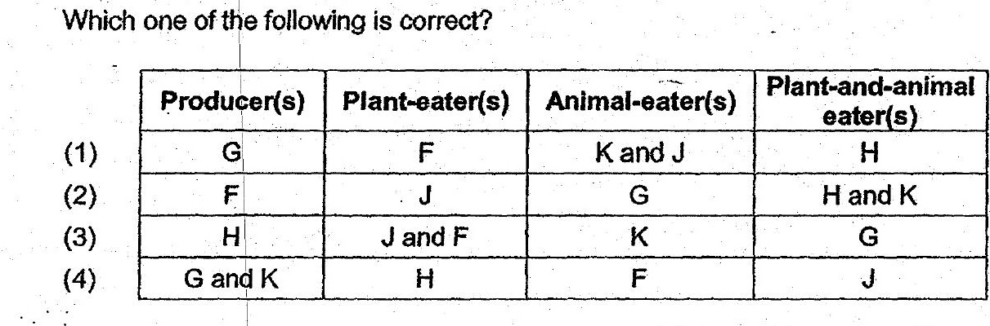

G6. . ‘Fhe picture below shows the structural adaptations of two plants.

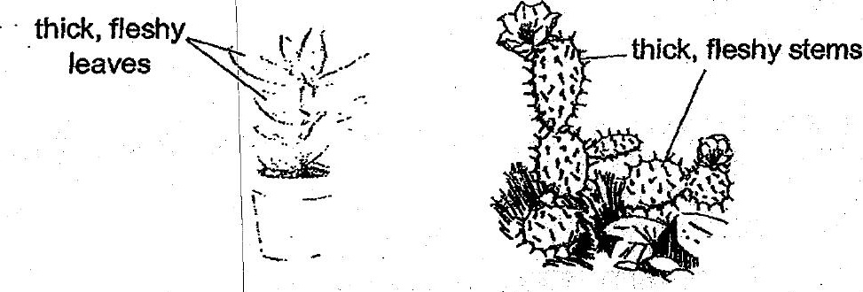

Which one of the folowing best explains the function of these adaptations? _  
  
(1) Adaptation for polintion, ee ee  
" (2) Adaptation|for reproduction. .  
  
(3). Adaptation for water retention. Oe  
  
(4) Adaptation for gétting suntight.