





(1) Sun |  
(2) Plant |  
  
(3) Water |  
  
(4) Carbon dioxide



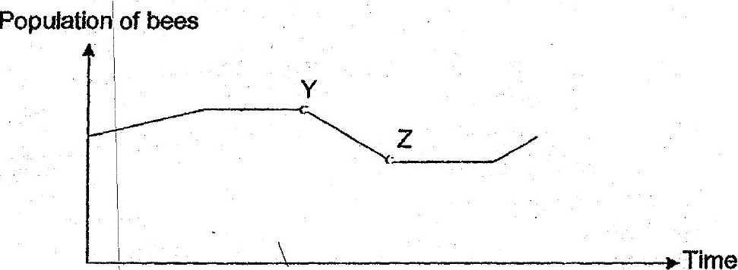





(1) Aand B only  
(2) Cand Donly  
(3) BandD only  
(4) A,B, CandD