

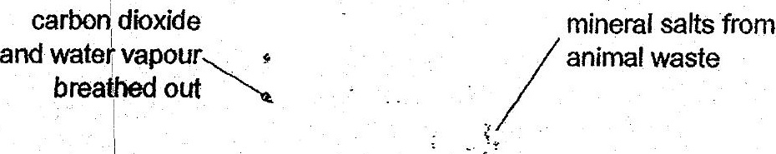

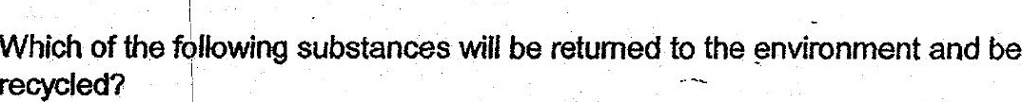

(1) Mineral salts only.  
  
(2). Minerat salts and water only.  
  
(3) Carbon bioxide and mineral salts only.  
(4). Carbon dioxide, mineral salis and water.



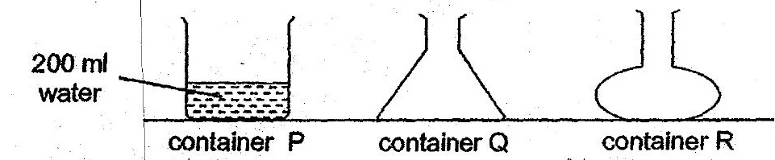

(1). She was frying to find out if water nas definite mass. .  
.@) ° She was tying to find out if water has a definite shape. ,  
  
(3) . She was trying to find out if water has a definite. volume.  
  
(4) She was trying to find out if water has definite mass and shape.