

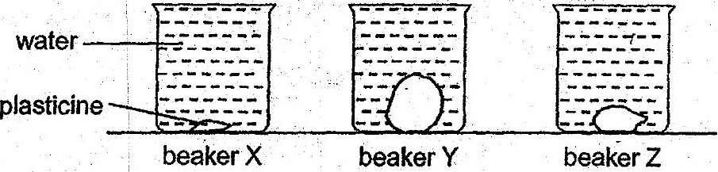



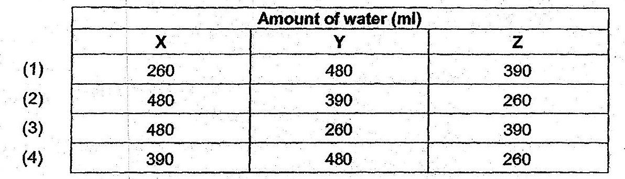

15. . Mei Ling wanted to investigate whether the size of a magnet affects the greatest  
distance. it can attract a paper clip.

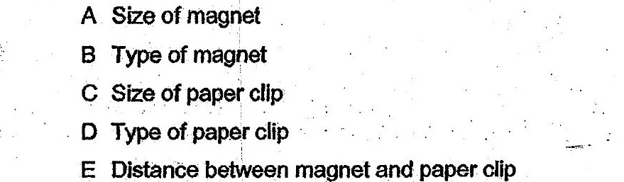

(1) Aonly  
  
(2) B, Cand D only,  
(3) A,B, D-and & only  
(4) B,C, DandE only