|: : :  
20. Four masses were tied fo four ropes made from different materials J, K, L and M as  
shown in the diagram below. The ropes were all of similar thickness. When the masses  
were lifted by the ropes, ropes K and L broke.

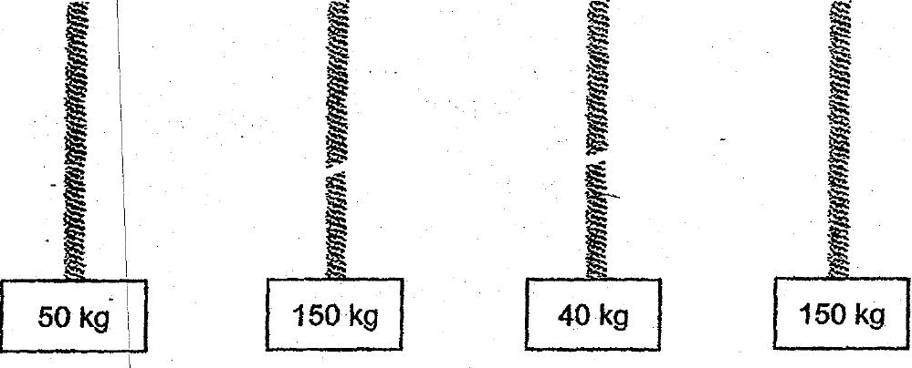

Which of the forewing statements is definitely true?  
-A Material L is the weakest.  
B Material Mis the strongest.  
—G Material J is stronger than material L.  
--D Material K is weaker than material M.  
: \

