ALL ANSWERS MUST BE IN COMPLETE SENTENCES UNLESS OTHERWISE STATED. |

29 How did the author first know thai the wails of the young child were very joud? [7m]

nee ee fay Pa +e Serer bre ENPYPPTUNNUueihdicnephnipastiper.

30 =©What had caused the young child io cry? [1m]

TOON Ea eee ee ey gS SSS SS fils gp rill lsd ahhh ill lth tcetheneeneenheanee

34 VVny dio the author need the young child to be still? (line $9) [im]

32. ~Look at the tabie below. Whai do ihe words in the left column refer to in the passage?  
Write your answers in the column in the right. (2m)

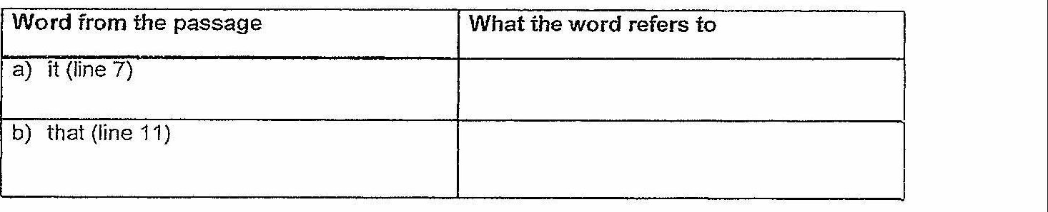

Question Word(s) from the passage  
a) Which word from the fourth paragraph  
tells us that the author saw a similarity  
between the lobster and excavaiors?  
b) Which two words from the fifth  
paragraph tell us what Grandma thoughi and  
of lobsters? Each word is found in a \  
separate sentence. |  
i

