25. Thediagram below shows a circuit with three similar bulbs A.B and C.

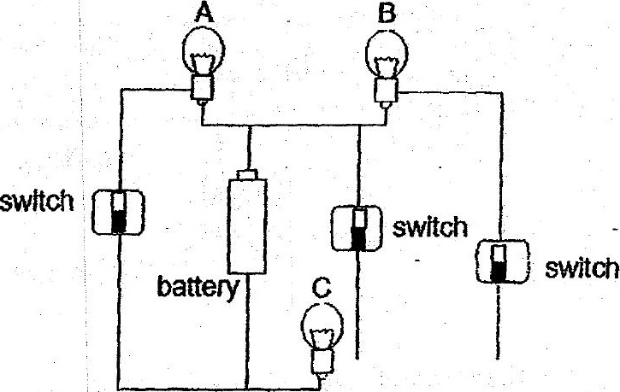

if only bulbs B and C are fit, which one of the following circuit diagrams correctly  
represents the circuit above?

