40. Hussein used a water collector to collect some water while on a trip to a desert.  
He placed the water collector in an open area in the evening and collected the  
water in the morning:

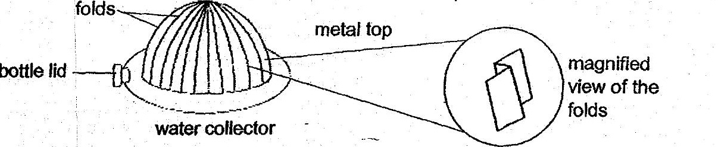

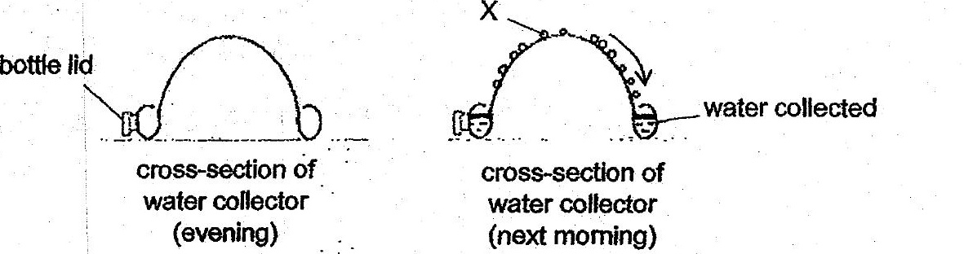

(b) - Explain why metal is used to make the fop part of the water collector. [2]

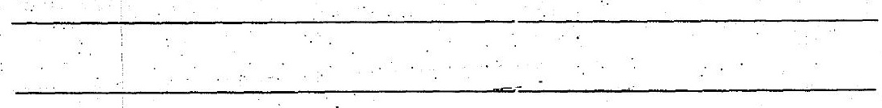

(c) Explain why there are folds in the metal top.

