| .  
41. The diagram below shows water heater A. The heating coil inside the tank is  
able to heat the water up to a temperature of 49 °C when the heater is turned  
_ on. The temperature of the water is then maintained at 49 °C until the heater is  
switched off. When the hot water tap is turned on, cold water enters the tank to  
replace the water used. -

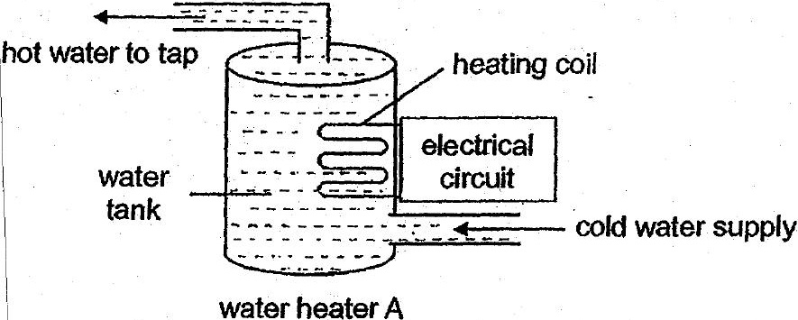

The graph below shows the temperature of the water in the tank over a period  
of time. | ‘

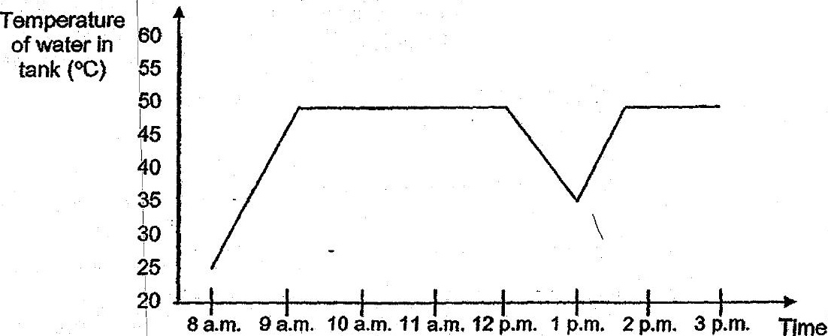

(a) How tong does it take for the water in the tank to heat up to 49°C? = [1]

(b) Jia Ming took.a bath. during the. period shown In the graph. Based onthe  
graph above, what fime did he probably take his bath? {t]