



(1) carry  
  
(2) carries  
  
(3) carrying  
  
(4) have carried

2 When, the results of the competition were announced, neither the winner nor his parents |  
at the hall.

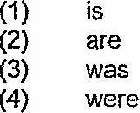



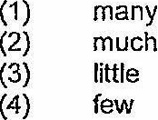

4 My grandmother managed to prepare a nutritions meal for us having only a few |  
in the refrigerator.

(1) despite  
  
(2) besides  
  
(3) because of  
(4) resulting from

2 With trepidation, Sarah watched the running boy the pail, spilling water all over |  
the floor.

(1} knock  
  
(2) knocks  
  
(3) knocked  
  
(4) was knocking

