S "You've put the carton of milk in the tefrigeraior, ?” Mrs Lim asked her daughier.

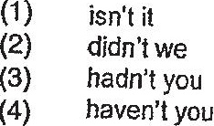

7 “| have never Such an interesting flower before,” exclaimed the old lady as she  
looked closely at it.

(1) see  
  
(2) saw  
  
(3) seen  
  
(4) been seeing

8 ifshe more water throughout the day, she would not have been dehydrated.

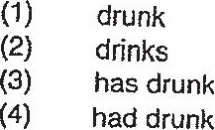

3 All of the luggage to the collection point except the one that belonged to the elderly  
bespectacled man. -

(1) Is delivering  
  
(2) was delivered  
  
(3) has been delivering  
(4) have been delivered

10 in order to be healthier, Mrs Chandra eliminated salty food and sugary drinks her  
diet.

