

44 The teacher praised Tom for being a pupil as he always checks his work carefully  
and submits his assignments on time.

(1) conscious  
(2) respeciful  
(3) productive  
(4) conscientious

12 The gangsters the homeless man by raining repeated blows on his head

(1) assaled  
(2) criticised  
(3) surrounded  
(4) approached

43 The teacher encouraged her pupils to read by sharing with them books on a wide  
variety of topics.

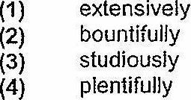

14 The shop assistants were relleved when the angry customer afier they  
apologised for their mistake.

(1) Dacked up  
(2) backed into  
(3) backed away  
(4) backed down

15 Although the doctors were of the opinion that the patient had a good chance of recovery, his  
condition rapidly after the operation.

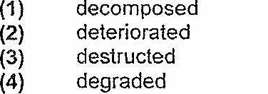

(Go on to the next page) |