

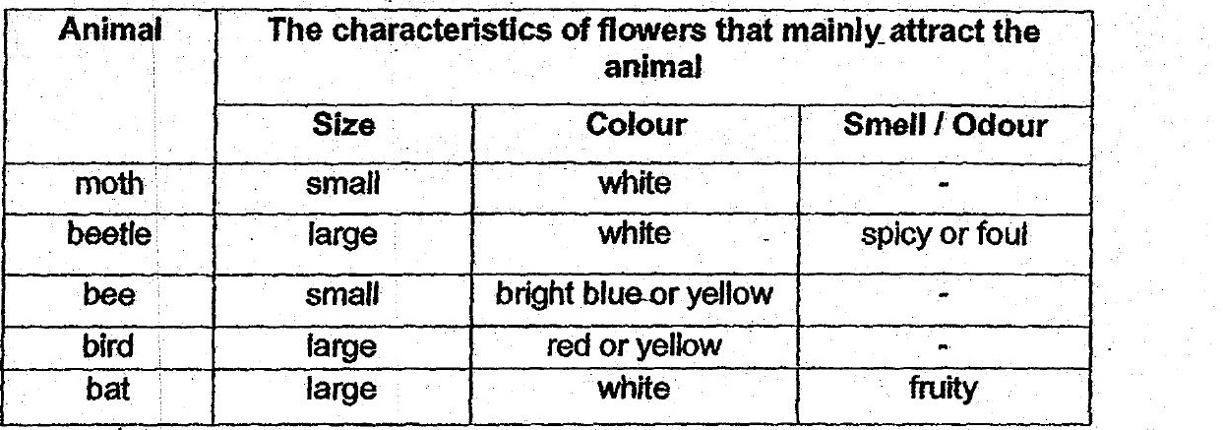

The chart below classifies five flowers A, B, C, D-and &.  
small large  
Te:  
bright blue or white white red or yellow \  
yellow '  
| Smell / Odour | co  
. spicy or foul - fruity ,

What:animals would be attracted to flowers.B and D respectively?

