For each question from 16 to 20, choose the word(s) closest in meaning to the underlined word(s).  
Shade your answer (1, 2, 3 or 4) on the Optical Answer Sheet.

| developed my love for watercolour painting when | was a child. On my sixth birthday, Dad  
gave me a palette of watercolour and that unleashed the magic of creative expressions in me. At  
first, | painted without a specific aim. ! was not particular about what | painted — my favourite stool,  
a memorable scene tome book | had read or even the banana | had for afternoon snack. As a  
result, my paintings did not tell a story. Then, | became more accomplished with practiceOnce, we  
went on a vacation to another country and Dad said that my colourful painting of a garden we visiied  
vas the best souvenir of the trip.  
With the encouragement of my parents and friends, my entiusiasm for painting grew.  
While | have received many compliments that my paintings are artistic, | continue io take lessons to  
improve my feqpqiaue.  
it is my dream to be a well-known artist one day.  
On

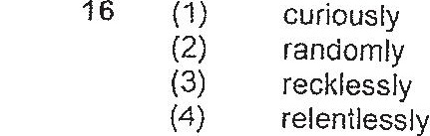

Tf (4) an undeniable  
(2) an irremovable  
(3) an unbelievable  
(4) an unforgeitable

