12. Study the diagram below.

carbon dioxide , mineral salts from  
and water vapour. « animal waste  
breathed out Ny Pe  
| x  
| iowt&

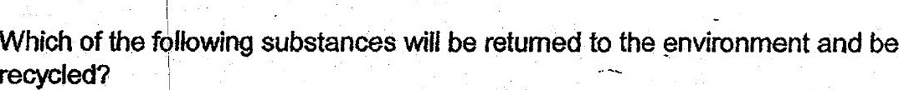

(1) Mineral salts only.  
  
(2). Minerat salts and water only.  
  
(3) Carbon bioxide and mineral salts only.  
(4). Carbon dioxide, mineral salis and water.

13. Jody poured 200 mi of water into container P as shown in the diagram below. She  
then poured all the water from container P to container Q. All the water was then  
poured out from container Q to container R.

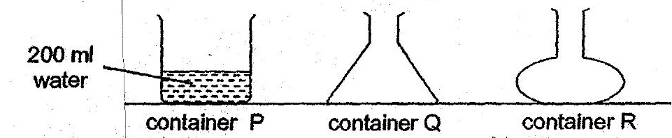

Which of the following best describes what Jody was trying to find out?

(1). She was frying to find out if water nas definite mass. .  
.@) ° She was tying to find out if water has a definite shape. ,  
  
(3) . She was trying to find out if water has a definite. volume.  
  
(4) She was trying to find out if water has definite mass and shape.