7... The table below shows the characteristics of some flowers which attract specific  
animals. ‘

Animal The characteristics of flowers that mainly attract the  
animal  
| _moth | small | white  
bird | aig rear yatiow  
pba arse white

The chart below classifies five flowers A, B, C, D.and E.

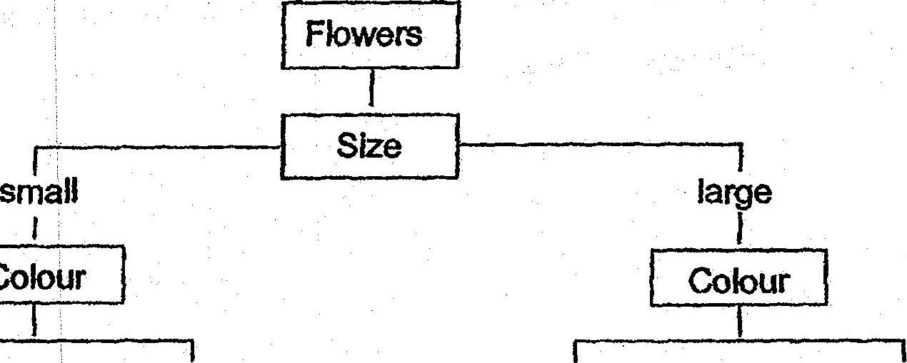

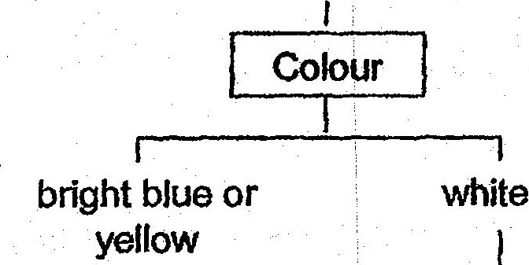

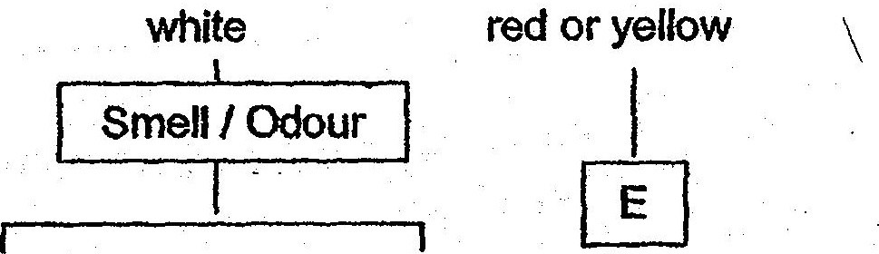

| spicy or foul - fruity a - -

What animals would be attracted fo flowers B and D respectively?

