34 Based on jines 18 to 24, state whether each statement in the table below is true or false,  
then give one reason why you think so. [3m]

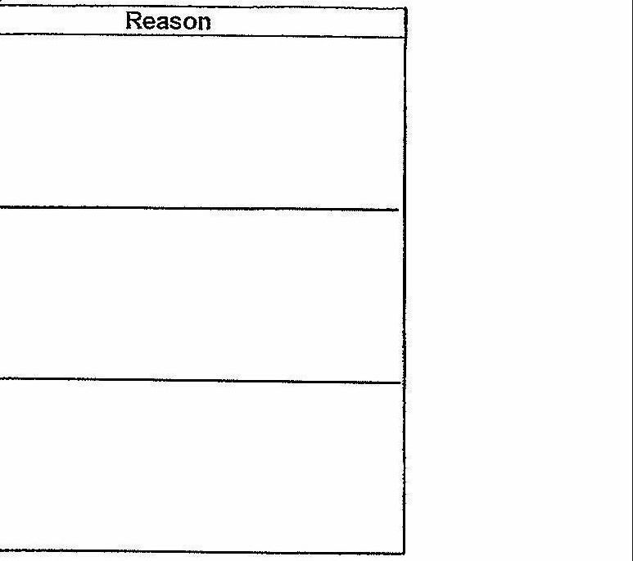

35 = Before Grandma called out for help, what were two actions by the author that showed he  
was in pain? [2m]  
Fill in each blank below with one action.

The author



LL Ty fe fei pF rneenerefmreters-



eT LL AL A fryer repertoire