24. Benjamin carried out an experiment using four set-ups A, 8, C and D as shown  
below. The water in all the beakers were at room temperature at first.

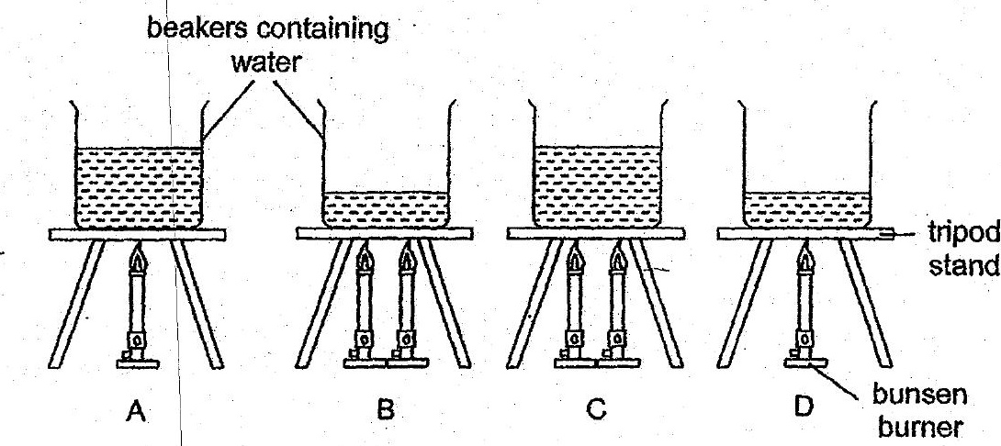

__ Inwhich set-up would the temperature of water be the lowest after 10 minutes of  
+ heating? |



. (3). c |  
(4) D