YEAR : 2019  
  
LEVEL : PRIMARY 6  
  
SCHOOL : CHIJ NICHOLAS GIRLS’ SCHOOL  
SUBJECT : ENGLISH  
  
TERM \*CAY

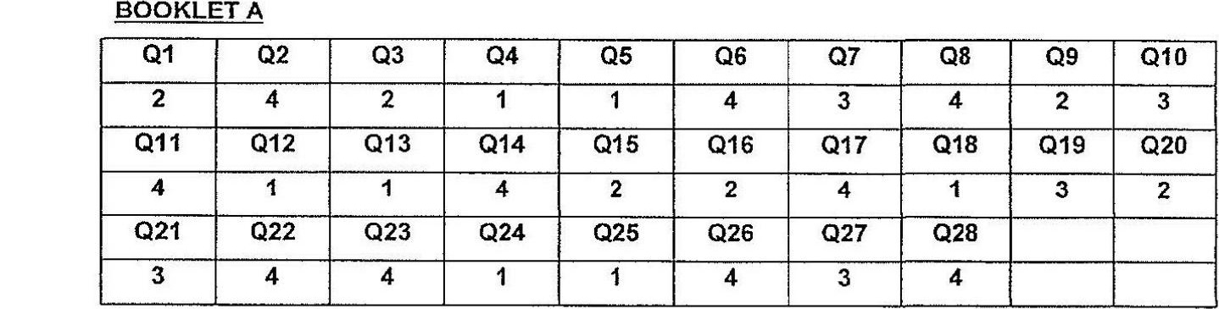

Q2o The author first knew that the waiis of the young child were very load because he  
had already heard the waits of the child resounding from the waiting room.  
  
Q30 The young child cried because a wasp stung her.  
  
Q31 The author needed the young child to be still because removing the needle-like  
object in one place would not be easy if the child would not calm down.  
  
Q32 a) The child’s finger  
b) When the author’s gaze came to rest on an old rubber toy.  
  
Q33 a) reminded  
b) tasty and mean  
  
Q34 a)True<> The fishmonger promoted the lobster to grandma.  
b) True <> Grandma and the fishmonger engaged in their animated chatter.  
c) False <> When the author lifted his hand and wanted to touch the lobster’s hard  
  
shell. The author was surprise that the lobster scuttled back a couple

Q35 = The author gave a loud well and jumped up with a start.  
  
Q36 Grandma was pleading for someone to help Ali pull the fobster off his finger.  
Q37 = The fishmonger did not think that anyone would buy a one-claw lobster, and the  
fishmonger was sure that the two-claw lobster could fetch a good price.  
  
Q38 a) kind

b) make the young girl fee! better.  
c) friend.

