CHIU ST NICHOLAS GIRLS’ SCHOOL

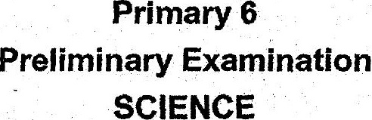



Do not open this booklet until you are told fo do.so.  
Follow alt instructions carefully.  
Answer all questions. .

{his pooklet consists.of 27 printed pages.