27. Tnediagram below shows a man throwing a ball.

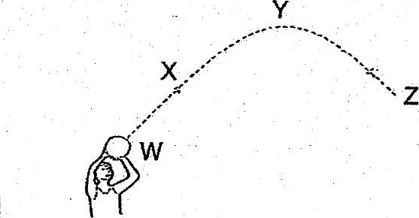

Which of the following statements is / are true?

A At point W, there is no force acting on the bail.  
B At point X, ball slows down because of gravity.  
C At point Y, the ball starts to drop as no force is acting on it.  
_ D At point Z, the ball drops further as frictional force is acting on it.

(1) Bonly  
  
(2) AandB only  
(3) Gand Donly  
(4) A,BandDonly

28. The diagram below shows a helicopter during the different stages of its flight.

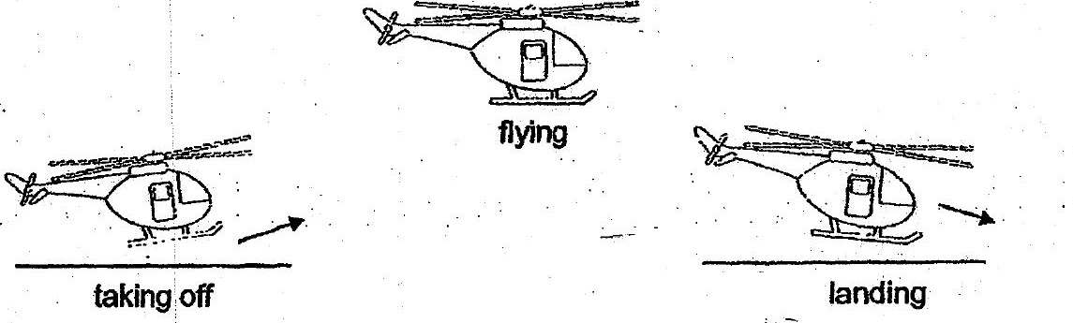

At which stage(s) does gravity act on the helicopter?

(1) ‘Landing only  
  
(2) Taking off and flying only  
  
(3) Taking off and landing only  
(4) _ Taking off, flying andanding