Giass : Primary 6

CHIU ST NICHOLAS GIRLS’ SCHOOL



BOOKLET 5S

’ Total Time for Booklet A and B: 1 hour 45 minutes - _.- | Booklet A oe  
13 questions Bookiét B |  
_ 44 marks : .  
Do not-open this booklet until you are told to do so. Total : m  
Follow all Instructions carefully. L 106 |

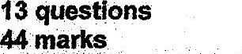

This paper consists of 15 printed pages.

Parent's Signature