30. A gardener observed a food relationship in his garden.

the gardener iearnt that another insect, M, is a predator of insect A. Insect M  
also likes fo feed on pollen. Using this information, he decided to grow plant H  
around plant K, as shown below.

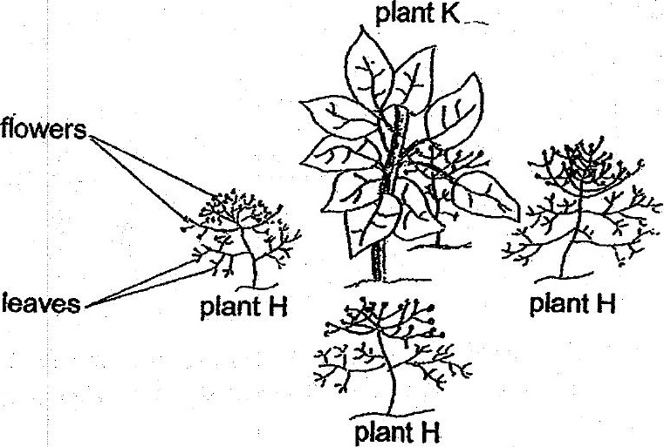

Based on the Information above, explain how this planting method allows the  
gardener to grow plant K without the use of pesticides? f2]

