35. Nathan made paper flyer A with a paper clip as shown in the diagram below.

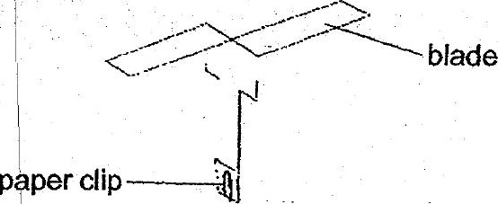

| _ paper fiyer A

He wanted to find out if the number of paper clips'Gn paper flyer A would affect  
the time it took to fall to the ground.

|  
(a) What must Nathan measure to help him draw a conclusion? {1]  
|

a Nathan threw paper flyer A with one paper clip and measured the distance it  
“ travelled. He then trimmed off 1 cm from each of the two blades of paper flyer  
  
= A and measured the distance it travelled when it was thrown from the same  
. height. |

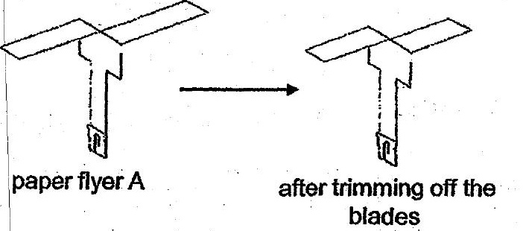

~ {b) Would the distance travelled by paper flyer A be affected after the blades  
. oo +. weretrimmed? Expiainyouranswer, = = = RJ...

|  
(c) Name one fruit or seed with a similar structure like paper flyer A. {1  
r

