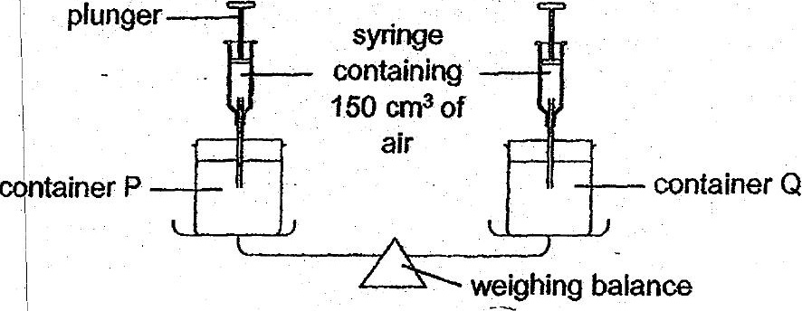

(a) What would be observed wien 150 cm? of air was pumped into container  
Q? | ff}

(D} State one property of air demonstrated by the experiment above. [7]



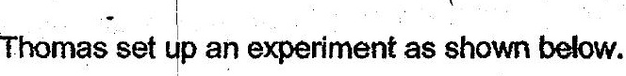

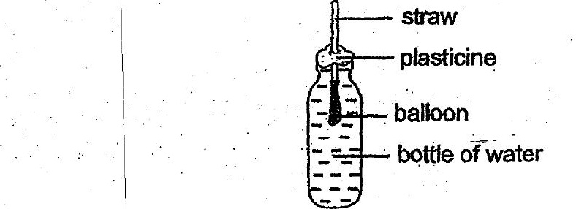

(c) Thomas tried to inflate the balloon by. blowing through the straw. Would  
the balloon inflafe? Give a reason for your answer. {]

