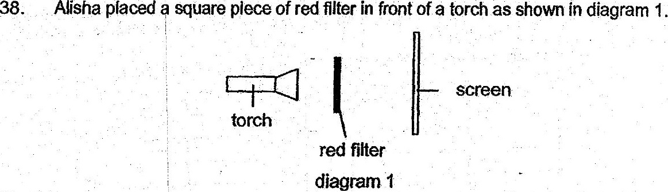

When the torch was switched on, she noted a Square. patch of light on the  
screen. She then repeated the same experiment with blue and green filters.  
  
+ Colour of filter used | Colour of square patch of light  
Pe  
ee ee  
  
(a) What was the aim of Alisha's experiment? {1]

Allsha then placed a can of drink behind a red filter as shown in diagram 2.

. me ue. black shadow  
. oo screen —_ Screen.  
torch ; oo, OT  
seal ele Se ~redpateh  
3: ped filter . Can ofdrink. . ot tignt  
digaram 2 diagram 3

(b). .. Diagram 3. shows what. she saw on the. screen when the forch was  
switched on. Give an explanation for Alisha’s observations in diagram 3.  
Ce : [2]

