10. Which one of the following adaptive features of the organisms is Incorrectly matched  
to its function? . |

17.. The diagram below shows the cross-section of a deep pond. ee

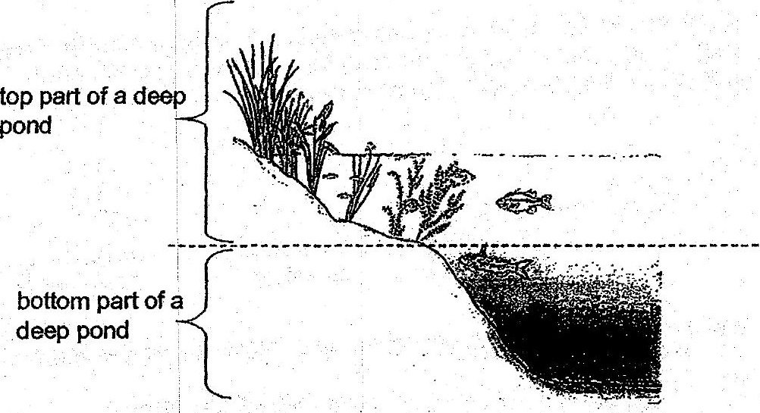

There are more aquatic plants found at the top part of the deep pond. What is the main  
reason for such an observation? . -

(i) | The aquatic plants can get sufficient nutrients to grow well.  
  
(2) | The aquatic plants can:absorb more sunlight for photosynthesis. /  
  
(3) The aquatic plants can take in oxygen from the air above the water,  
  
(4). Thé aquatic plants can provide shade and shelter for the aquatic animals living  
in-the:pond.