32. ~Look at the tabie below. Whai do ihe words in the left column refer to in the passage?  
Write your answers in the column in the right. (2m)

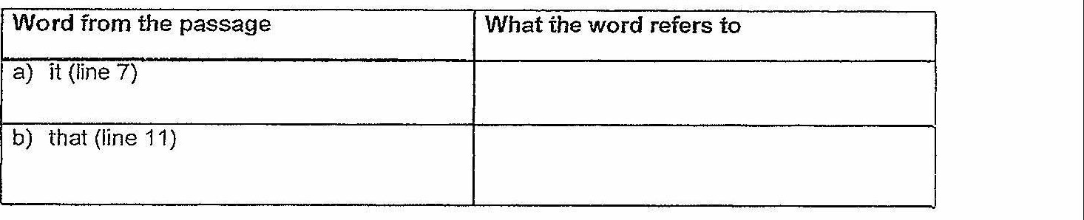

Question Word(s) from the passage  
a) Which word from the fourth paragraph  
tells us that the author saw a similarity  
between the lobster and excavaiors?  
b) Which two words from the fifth  
paragraph tell us what Grandma thoughi and  
of lobsters? Each word is found in a \  
separate sentence. |  
i

(GO on to the nexi page} |