34 Based on jines 18 to 24, state whether each statement in the table below is true or false,  
then give one reason why you think so. [3m]

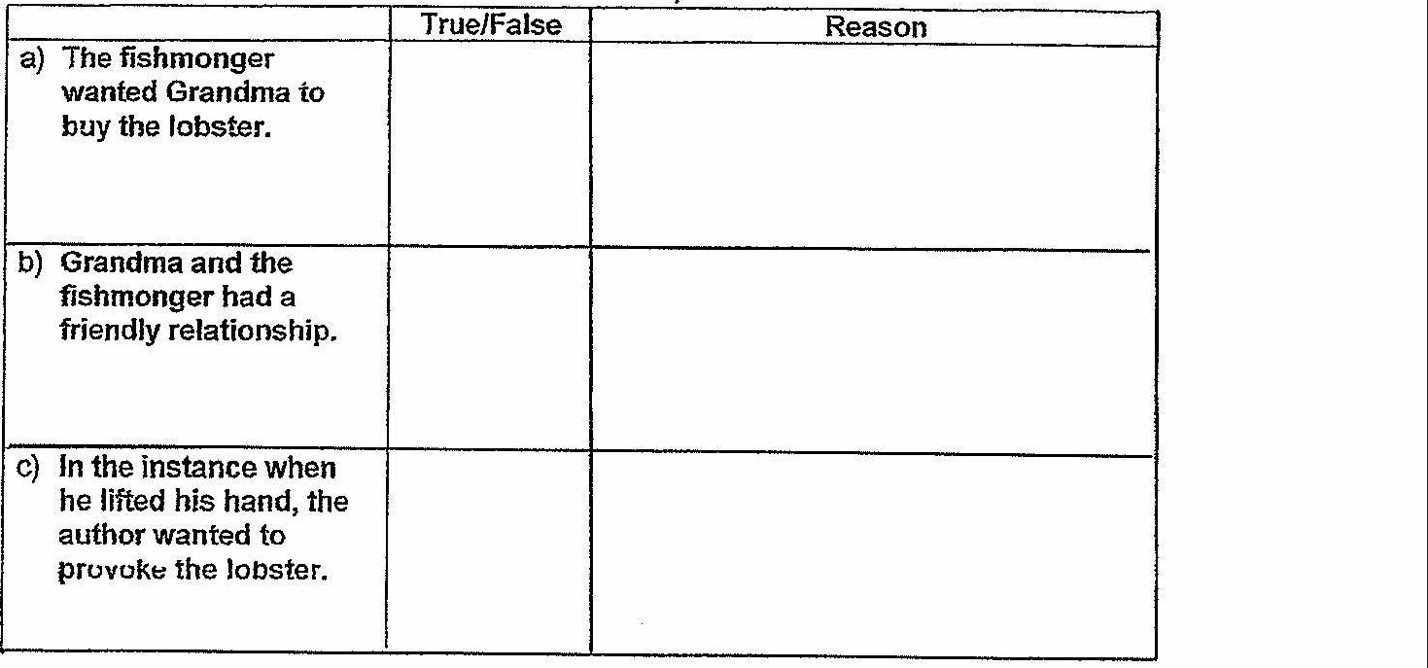

35 = Before Grandma called out for help, what were two actions by the author that showed he  
was in pain? [2m]  
Fill in each blank below with one action.

The author

36 0 \*...Grandma's anxious plea for intervention” (lines 27 and 28). What was Grandma pleading  
for? [2m}

C—O LL RA ne ry ree

LL Ty fe fei pF rneenerefmreters-

3F Why was the fishmonger unwilling io chop off the claw of the lobster? Give two reasons.  
{2m}

ee LL A y-ray ieee perp

eT LL AL A fryer repertoire

[Go on to the rext paged |