



CHIJ ST NICHOLAS GIRLS’ SCHOOL (PRIMARY)

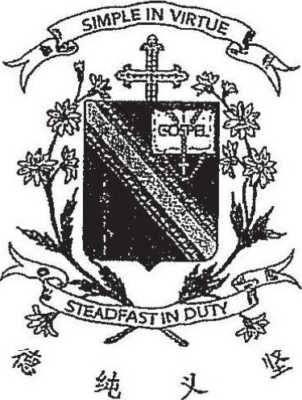





25 February 2019





Duration of Paper (Booklets A & B): 1h 30 min

28 questions  
28 marke

Instructions fo Candidates:  
  
Do not open this booklet until you are told to do so.  
Follow all instructions carefully.  
  
Answer all questions.

iis booklet consists of 10 printed pages and 1 blank page.