For each question from 16 to 20, choose the word(s) closest in meaning to the underlined word(s).  
Shade your answer (1, 2, 3 or 4) on the Optical Answer Sheet.

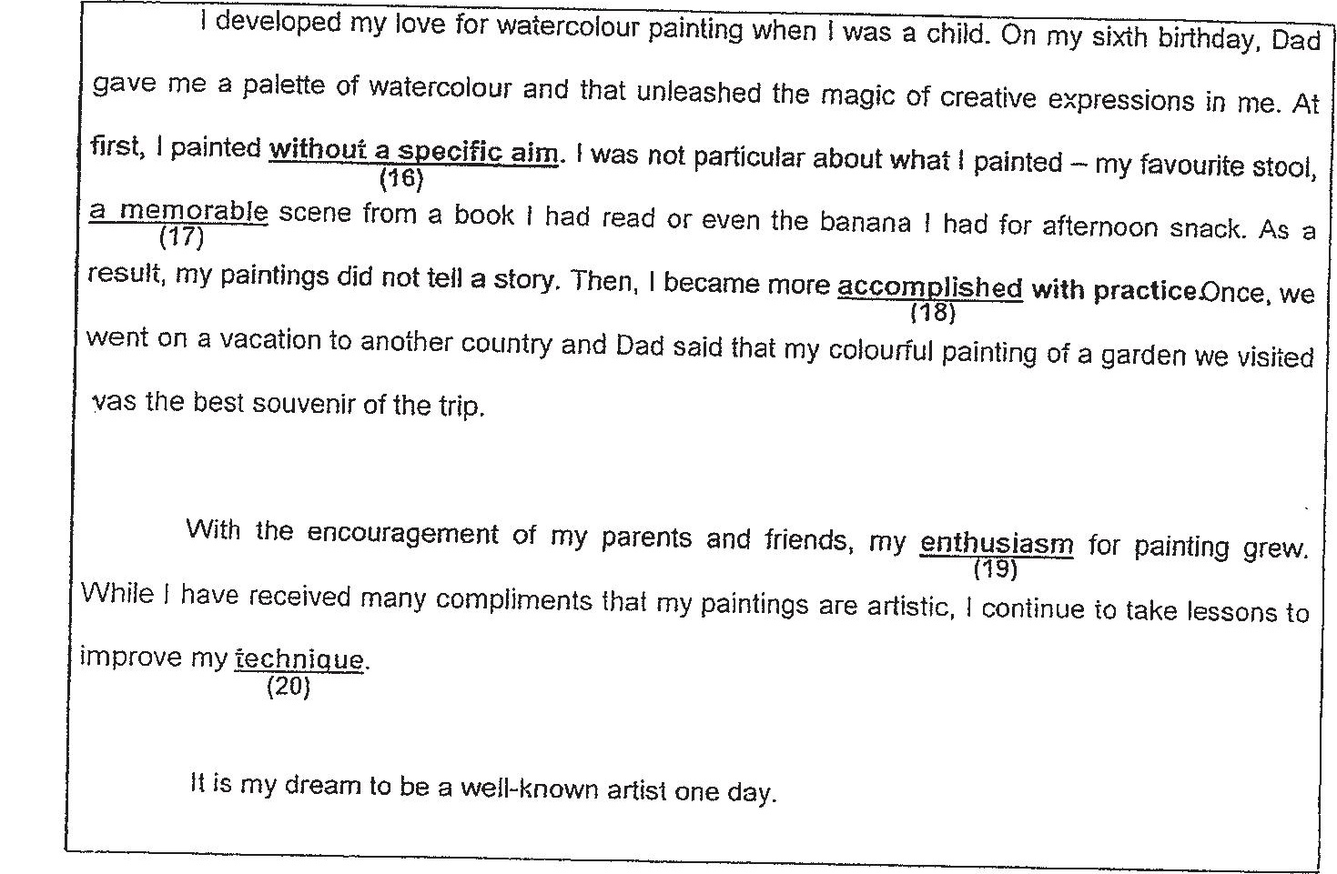

76 (1) curiously  
(2) randomly  
(3) recklessly  
(4) relentlessly

Tf (4) an undeniable  
(2) an irremovable  
(3) an unbelievable  
(4) an unforgeitable

43d (1) adepi  
(2) perfect  
(3) correct  
(4) accurate

(‘Go on to the nexi page)