16. Thediagram below shows a wooden rod with a magnet P and iron ball Q hanging from  
a rope. |

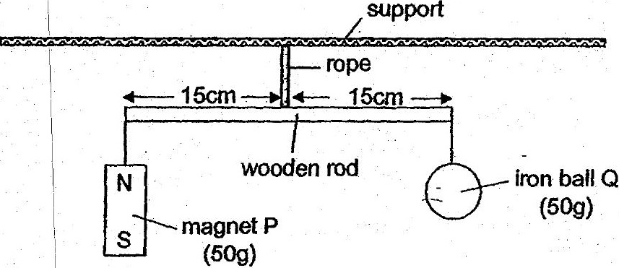

Which one of ine following statements Is faise’?

(1) When the north pole of another magnet is placed under magnet P, the  
wooden rod will tilt towards magnet P. ---  
  
(2) When the north pole of another magnet is.placed under iron ball Q, the  
wooden red will tilt fowards magnet P. ©":  
  
{3) | When the south pole of another magnet is placed under magnet P, the  
wooden rod will tilt towards iron ball Q.  
  
(4) When the south pole of another magnet is placed. under tron-ball-Q, the  
wooden rod will tit towards iron ball Q.

7 | x m4  
\: ,