17. — Jim placed a coin at the botiom of a beaker as shown in the diagram below. He then  
  
_ poured some water from river X into the beaker slowly and observed the coin from  
  
above the beaker. He stopped pouring when he could not see the coin. clearly and  
recorded the amount of water in.the beaker.

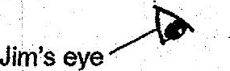

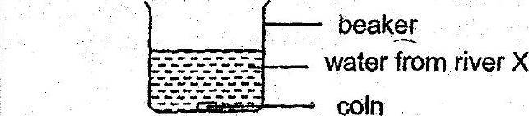

He repeated the same experiment with water from rivers Y and Z. The table below  
shows the results.

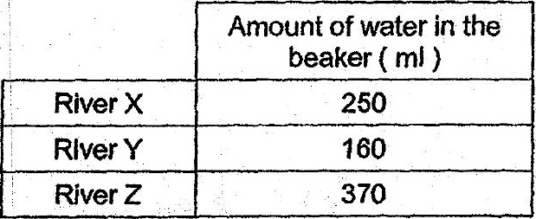

Based on Jim’s results, which of the following shows the clarity of water from rivers X,  
Y and 7 in the correct order?

