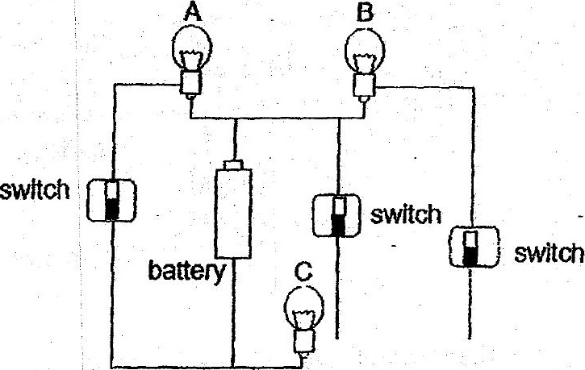

if only bulbs B and C are fit, which one of the following circuit diagrams correctly  
represents the circuit above?

