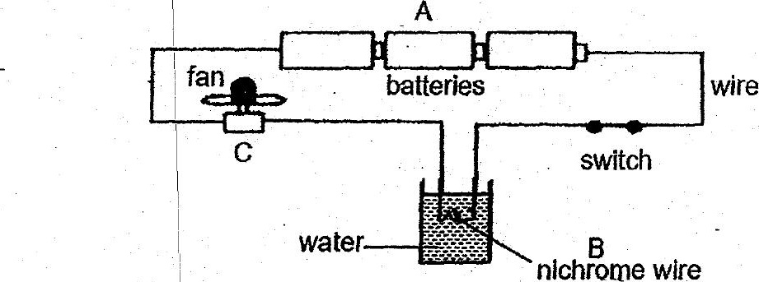

ot +  
When the switch was closed, the fan started moving and the water in the  
contalner was slowly heated up.

What were the main energy changes that had taken place at each point labelled  
Ato C? i

PA  
:  
(1) Chemical potential energy | Electrical energy > Kinetic energy >  
> electrical energy light energy sound energy  
(2) Electrica energy > kinetic | Electrical energy > | Electrical energy >  
. energy . light energy sound energy  
| :  
|  
. (3) Chemical potential energy | Electrical energy > | Electrical energy >  
> efectrical energy heat energy kinetic energy  
; |  
(4) Electrical energy > kinetic | Heat energy > light | Kinetic energy > _  
| energy energy heat + sound energy